BUSINESS INTELLIGENCE PROJECT

ANALYSIS ON

LIFE EXPECTANCY ACROSS COUNTRIES BY WHO

**SUBMITTED BY**

AAYUSHI BHARTI

# ABOUT DATASET

Data contains life expectancy, health, immunization, and economic and demographic information about **179 countries** from **2000-2015 years**. The adjusted dataset has **21 variables** and **2.864 rows**.

Source of dataset: <https://www.kaggle.com/datasets/lashagoch/life-expectancy-who-updated>

The dataset had inaccurate data and a lot of values were missing.

The dataset is completely updated.

Data about Population, GDP, and Life Expectancy was updated according to World Bank Data. Information about vaccinations for Measles, Hepatitis B, Polio, and Diphtheria, alcohol consumption, BMI, HIV incidents, mortality rates, and thinness were collected from World Health Organization public datasets. Information about Schooling was collected from the Our World in Data which is a project of the University of Oxford.

The database has one variable that categorizes countries into two groups: **Developed vs Developing** countries. According to World Trade Organization, each country [defines](https://www.wto.org/english/tratop_e/devel_e/d1who_e.htm) itself as “Developed” or “Developing”. Therefore, it is challenging to categorize countries. UN has a [list](https://www.un.org/en/development/desa/policy/wesp/wesp_current/2014wesp_country_classification.pdf) dated 2014 that for analytical purposes classifies countries as developed, in transition, and developing economies. Countries that have economies in transition have similar characteristics to the countries that are categorized as developed or developing countries. Countries have been grouped according to their Gross National Income per capita. As a result, nations were divided into four income groups: high-income, higher-middle-income, lower-middle-income, and low-income. The levels of Gross Domestic Income are set by the World Bank to ensure comparability.

The dataset contains the following columns:

* **Country:** Name of the country.
* **Region:** Geographical region of the country.
* **Year:** Year of data collection.
* **Infant_deaths**: Number of deaths of infants under 1 year old.
* **Under_five_deaths:** Number of deaths of children under 5 years old.
* **Adult_mortality:** Mortality rate of adults aged 15-60.
* **Alcohol_consumption:** Per capita alcohol consumption.
* **Hepatitis_B:** Immunization coverage for Hepatitis B.
* **Measles:** Number of reported measles cases.
* **BMI:** Average Body Mass Index of the population.
* **Polio:** Immunization coverage for Polio.
* **Diphtheria:** Immunization coverage for Diphtheria.
* **Incidents_HIV:** Number of new HIV infections.
* **GDP_per_capita:** Gross Domestic Product per capita.
* **Population_mln:** Population size in millions.
* **Thinness_ten_nineteen_years:** Prevalence of thinness among adolescents aged 10-19.
* **Thinness_five_nine_years:** Prevalence of thinness among children aged 5-9.
* **Schooling:** Average number of years of schooling.
* **Economy_status_Developed:** Indicator of developed economic status.
* **Economy_status_Developing:** Indicator of developing economic status.
* **Life_expectancy:** Average life expectancy at birth.

# METHODOLOGIES

Each analysis model is chosen based on the type of relationship and the nature of the variables involved:

* **Linear Regression**: Suitable for analyzing continuous dependent variables with one or more continuous or categorical independent variables.
* **Multiple Linear Regression**: Extends linear regression to include multiple independent variables.

|  |  |
| --- | --- |
| **Objective** | **Model** |
| Analyze the impact of healthcare factors on life expectancy | Multiple Linear Regression |
| Evaluate the relationship between economic status and life expectancy | Multiple Linear Regression |
| Investigate the effect of education on life expectancy | Linear Regression |
| Assess the influence of nutritional factors on child mortality | Multiple Linear Regression |
| Examine the effect of alcohol consumption on adult mortality | Linear Regression |

# FILE UPLOAD ON SAS

The steps followed:

Create New Library < Create Path in Files < Import File

CODE:

FILENAME REFFILE '/home/u63905639/C2/crop_yield.csv';

PROC IMPORT DATAFILE=REFFILE

DBMS=CSV

OUT=C2CROP.IMPORT;

GETNAMES=YES;

RUN;

PROC CONTENTS DATA=C2CROP.IMPORT; RUN;

%web_open_table(C2CROP.IMPORT);

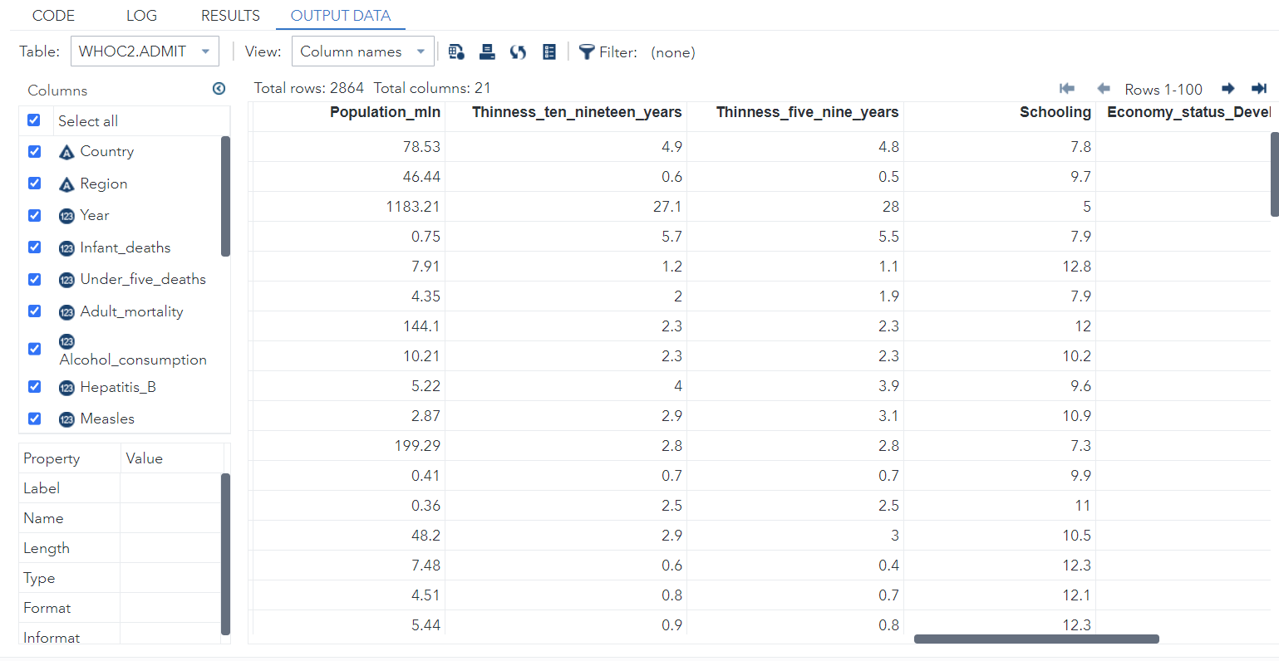

# TABLE ATTRIBUTES

The steps followed:

Task & utilities < Data < List table attributes

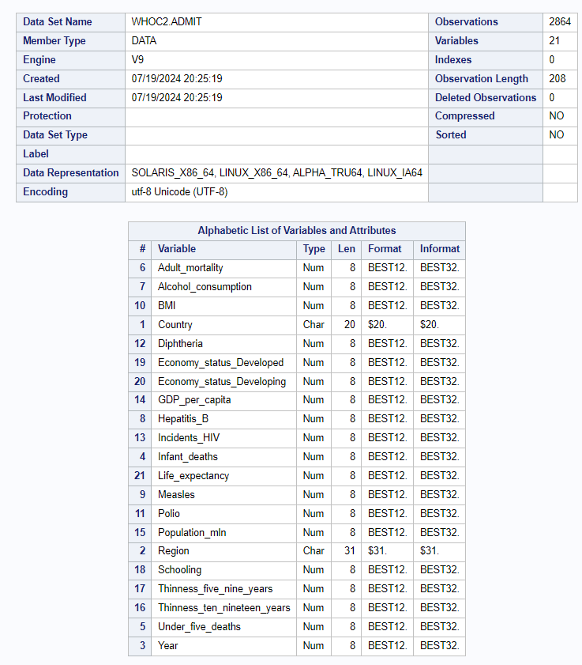

We can infer that there are a total of 21 variables, out of which there are 19 Numerical variables and 3 Categorical variables.

# CHECKING ANY MISSING DATA

The steps followed: Task & utilities < Data < Describe Missing Data

There are no missing values in the dataset. So, now we can move forward with our analysis.

# Objective 1: Analyze the impact of healthcare factors on life expectancy

**Variables Involved**: Infant_deaths, Under_five_deaths, Adult_mortality, Incidents_HIV, Hepatitis_B, Measles, Polio, Diphtheria, Life_expectancy

**Model**: Multiple Linear Regression

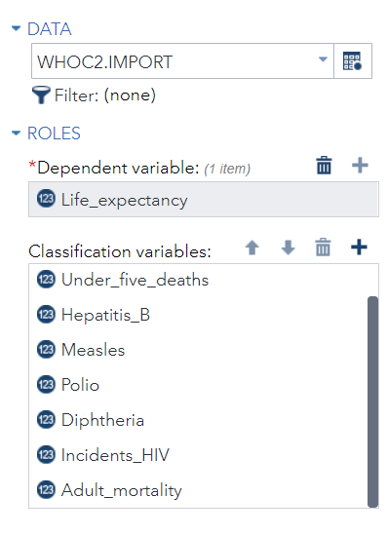**Interpretation and Inferences**:

* Determine how various healthcare factors (infant deaths, under-five deaths, adult mortality, disease incidents, etc.) affect life expectancy.
* Identify which healthcare factors have the most significant impact on life expectancy.
* Provide insights for public health policies to improve life expectancy.

## CAN WE RUN REGRESSION?

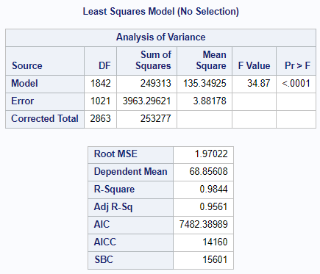We can run regression. The results are a good fit at 95% confidence level for analysis at R-Square 0.98 and Adjusted R-Square at 0.95. It confirms the conditions of multiple linear regression where R-Square should be greater than 0.90 and Adjusted R-Square should be less than or equal to R-Square.

CODE:

ods noproctitle;

ods graphics / imagemap=on;

proc glmselect data=WHOC2.IMPORT outdesign(addinputvars)=Work.reg_design;

class Infant_deaths Under_five_deaths Hepatitis_B Measles Polio Diphtheria

Incidents_HIV Adult_mortality / param=glm;

model Life_expectancy=Infant_deaths Under_five_deaths Hepatitis_B Measles

Polio Diphtheria / showpvalues selection=none;

run;

proc reg data=Work.reg_design alpha=0.05 plots(only)=(diagnostics residuals

observedbypredicted);

where Infant_deaths is not missing and Under_five_deaths is not missing and

Hepatitis_B is not missing and Measles is not missing and Polio is not

missing and Diphtheria is not missing and Incidents_HIV is not missing and

Adult_mortality is not missing;

ods select DiagnosticsPanel ResidualPlot ObservedByPredicted;

model Life_expectancy=&_GLSMOD /;

run;

quit;

proc delete data=Work.reg_design;

run;

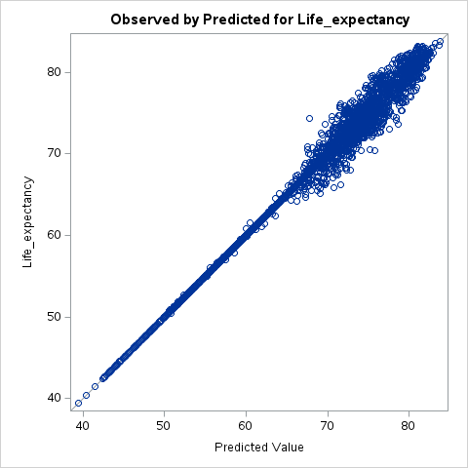This plot shows the observed life expectancy values on the y-axis versus the predicted life expectancy values on the x-axis.

**Good Fit**: The points closely follow the diagonal line, indicating a good fit between the observed and predicted values.

**Few Outliers**: There are very few outliers, suggesting that the model predictions are accurate.

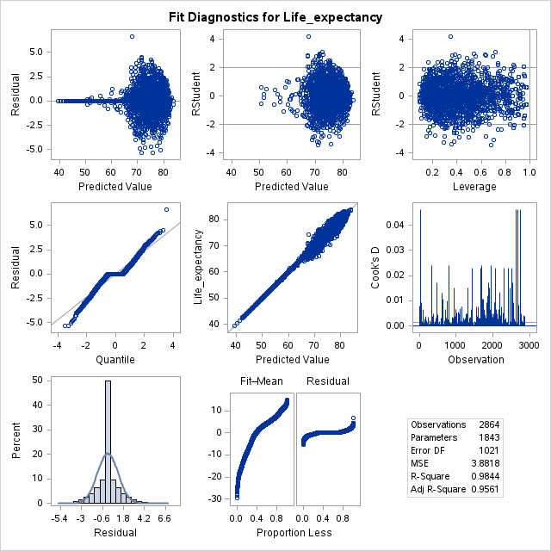

### Fit Diagnostics for Life Expectancy

**Residuals vs. Predicted**: The residuals are randomly scattered around zero, indicating homoscedasticity (constant variance of errors).

**Q-Q Plot**: The points on the Q-Q plot closely follow the diagonal line, suggesting that the residuals are normally distributed.

**Residuals vs Leverage**: There are no high leverage points that would unduly influence the model.

**Cook's Distance**: Most observations have low Cook's distance values, indicating no influential outliers.

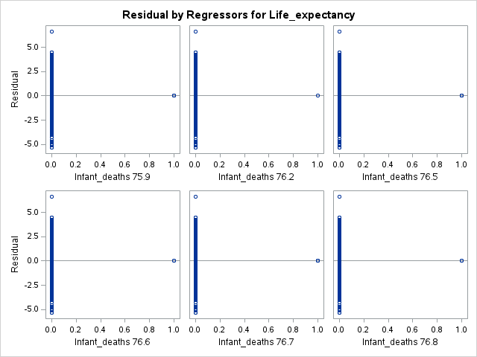These plots show the residuals (errors) for life expectancy predictions against the categorical variable ‘Infant deaths’

**Consistent Residuals**: The residuals are fairly consistent and centered around zero for each country, indicating no systematic error across different infant deaths.

**No Significant Bias**: There is no significant bias in the residuals, suggesting the model is performing uniformly across all infant death values.

**INFERENCE 1:** To determine which variable has the most correlation with life expectancy using the Schwarz Bayesian Criterion value. The SBC is a criterion for model selection among a finite set of models; the optimal value of the criterion (*) is the lowest SBC, which indicates the best model fit.

From the table we see that the variable ‘Infant deaths’ has the lowest SBC value (12299.3491), suggesting that it has the most significant effect on life expectancy among the variables included in your analysis.

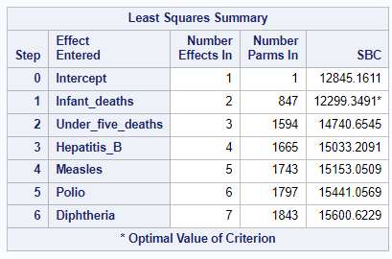

**INFERENCE 2**: The number of infant deaths across 9 regions of this world over the span of 15 years.

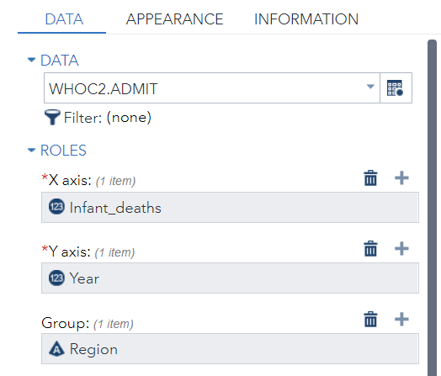Asia has the greatest number of infant deaths all through 15 years, while only Central America and Caribbean too saw the most infant deaths in the year of 2010.

CODE:

proc sgplot data=WHOC2.ADMIT;  
 scatter x=Infant_deaths y=Year / group=Region;  
 xaxis grid;  
 yaxis grid;  
run;  
  
ods graphics / reset;

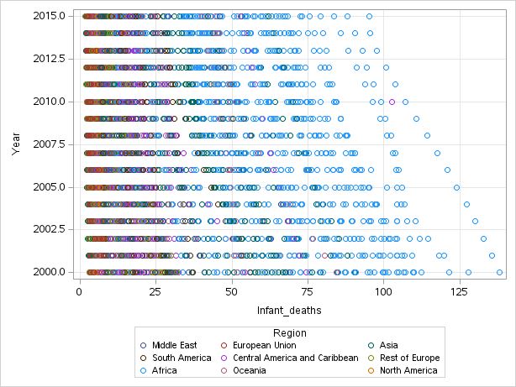

**INFERENCE 2:** The number of adult deaths across 9 regions of this world over the span of 15 years and how it affects the life expectancy.

CODE:

proc means data=WHOC2.ADMIT noprint;

class Region / order=data;

var Adult_mortality Life_expectancy;

output out=_BarLine_(where=(_type_ > 0)) mean(Adult_mortality

Life_expectancy)=resp1 resp2;

run;

/* Compute response min and max values (include 0 in computations) */

data _null_;

retain respmin 0 respmax 0;

retain respmin1 0 respmax1 0 respmin2 0 respmax2 0;

set _BarLine_ end=last;

respmin1=min(respmin1, resp1);

respmin2=min(respmin2, resp2);

respmax1=max(respmax1, resp1);

respmax2=max(respmax2, resp2);

if last then

do;

call symputx ("respmin1", respmin1);

call symputx ("respmax1", respmax1);

call symputx ("respmin2", respmin2);

call symputx ("respmax2", respmax2);

call symputx ("respmin", min(respmin1, respmin2));

call symputx ("respmax", max(respmax1, respmax2));

end;

run;

/* Define a macro for offset */

%macro offset ();

%if %sysevalf(&respmin eq 0) %then

%do;

offsetmin=0 %end;

%if %sysevalf(&respmax eq 0) %then

%do;

offsetmax=0 %end;

%mend offset;

ods graphics / reset width=6.4in height=4.8in imagemap;

proc sgplot data=WHOC2.ADMIT nocycleattrs;

vbar Region / response=Adult_mortality stat=mean;

vline Region / response=Life_expectancy stat=mean y2axis;

yaxis grid min=&respmin1 max=&respmax1 %offset();

y2axis min=&respmin2 max=&respmax2 %offset();

keylegend / location=outside;

run;

ods graphics / reset;

proc datasets library=WORK noprint;

delete _BarLine_;

run;

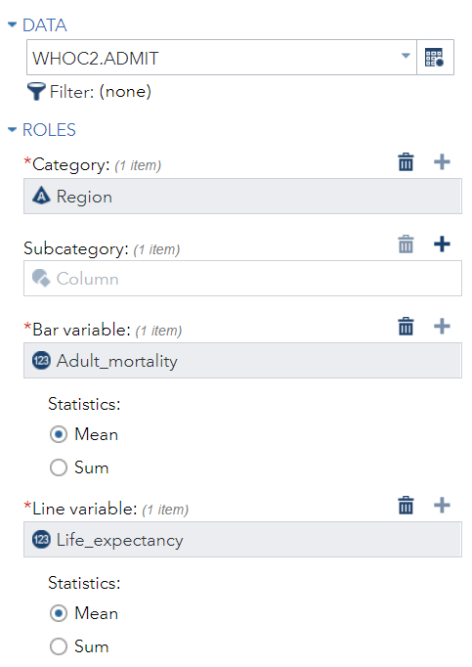

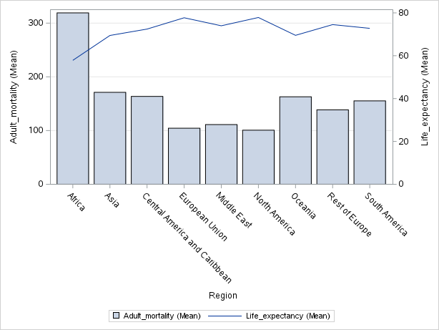Africa has the highest Adult Mortality rate, due to which the Life Expectancy is the least in this region.

### Insights for public health policies to improve life expectancy.

**Reduce Infant Mortality**:

* **Policy Focus**: Implement targeted interventions to reduce infant deaths, such as improving prenatal and neonatal care.

**Enhance Vaccination Programs**:

* **Policy Focus**: Strengthen immunization efforts for diseases like Hepatitis B, Polio, and Measles to reduce mortality rates.

**Promote Education and Nutrition**:

* **Policy Focus**: Invest in educational programs and nutritional support to address child malnutrition and improve overall health outcomes.

# Objective 2: Evaluate the relationship between economic status and life expectancy

**Variables Involved:** GDP_per_capita, Economy_status_Developed, Economy_status_Developing, Life_expectancy

**Model:** Multiple Linear Regression

**Interpretation and Inferences:**

* Assess how GDP per capita influences life expectancy in different economic statuses.
* Provide economic insights for improving life expectancy in developing countries.

## CAN WE RUN REGRESSION?

We can run regression. The results are a good fit at 95% confidence level for analysis at R-Square 0.95 and adjusted R-square less than R-square at 0.57.

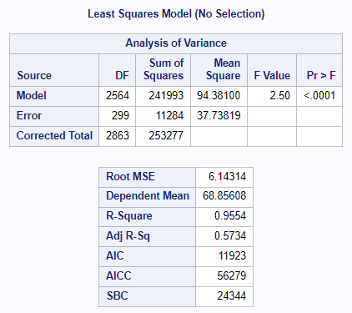

CODE:

/* Multiple Linear Regression to evaluate the relationship between economic status and life expectancy */  
proc glm data=WHOC2.ADMIT;  
 class Economy_status_Developed Economy_status_Developing;  
 model Life_expectancy = GDP_per_capita Economy_status_Developed Economy_status_Developing;  
 title "Multiple Linear Regression for Economic Status and Life Expectancy";  
run;  
  
/* Generating interaction plots */  
proc sgplot data=WHOC2.ADMIT;  
 scatter x=GDP_per_capita y=Life_expectancy / group=Economy_status_Developed;  
 reg x=GDP_per_capita y=Life_expectancy / group=Economy_status_Developed;  
 title "Scatter Plot with Regression Line for GDP per Capita and Life Expectancy by Developed Status";  
run;  
  
proc sgplot data=WHOC2.ADMIT;  
 scatter x=GDP_per_capita y=Life_expectancy / group=Economy_status_Developing;  
 reg x=GDP_per_capita y=Life_expectancy / group=Economy_status_Developing;  
 title "Scatter Plot with Regression Line for GDP per Capita and Life Expectancy by Developing Status";  
run;

**INFERENCE:** The countries with low GDP per capita have low life expectancy compared to the countries with high GDP per capita with high life expectancy.

There's a positive relationship between GDP per capita and life expectancy in both developed and developing countries.

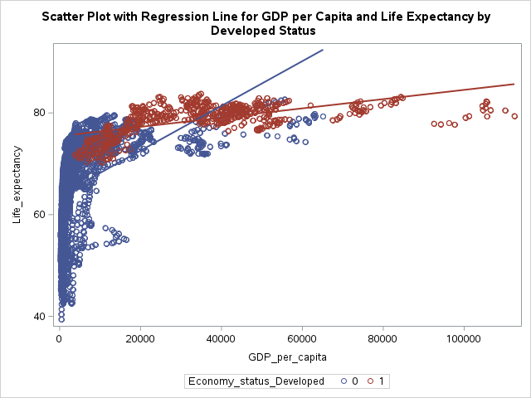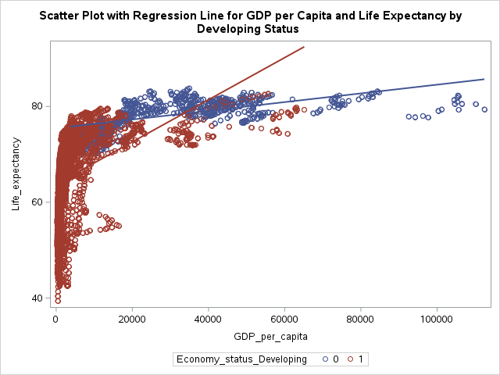

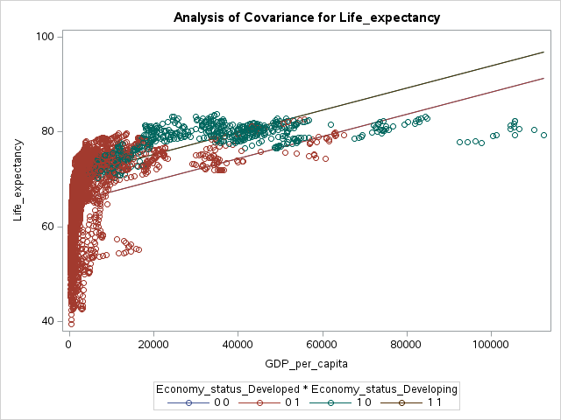

**Differences by Economic Status**:

* In developed countries, life expectancy increases with GDP but plateaus at higher levels, indicating diminishing returns.
* In developing countries, the increase in life expectancy with GDP is more pronounced at lower levels.

**Comparison**:

* Developed countries have higher life expectancy at similar GDP levels compared to developing countries.
* The impact of GDP growth on life expectancy is more significant in developing countries.

### Economic insights for improving life expectancy in developing countries

1. **Invest in Healthcare Infrastructure and Services**:
   * Enhance access to primary healthcare, especially in rural areas.
   * Increase healthcare funding to improve service quality and availability.
   * Focus on preventive health programs like vaccinations and maternal care.
2. **Enhance Education and Awareness**:
   * Promote health education on hygiene, nutrition, and disease prevention.
   * Empower women through education to make informed health choices.
   * Engage communities in health initiatives for better acceptance and effectiveness.
3. **Implement Economic Policies and Social Protection**:
   * Reduce poverty and inequality to improve access to healthcare and nutrition.
   * Establish social protection programs like health insurance and cash transfers.
   * Invest in clean water and sanitation infrastructure to prevent diseases.

Objective 3: Investigate the effect of education on life expectancy

**Variables Involved**: Schooling, Life_expectancy

**Model**: Linear Regression

**Interpretation and Inferences:**

* Analyze the correlation between years of schooling and life expectancy.
* Suggest educational policies to enhance life expectancy.

## CAN WE RUN REGRESSION?

* **Dependent Variable**: Life_expectancy
* **Classification Variable**: Schooling

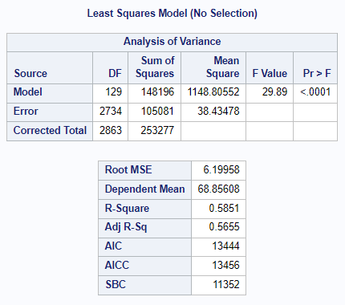We can run regression but the results might not satisfy the objective. The results at 95% confidence level for analysis are with R-Square 0.58, and Adjusted R-Square is less than R-Square at 0.56.

CODE:

proc glmselect data=WHOC2.ADMIT outdesign(addinputvars)=Work.reg_design;

class Schooling / param=glm;

model Life_expectancy=Schooling / showpvalues selection=none;

run;

proc reg data=Work.reg_design alpha=0.05 plots(only)=(diagnostics residuals

observedbypredicted);

where Schooling is not missing;

ods select DiagnosticsPanel ResidualPlot ObservedByPredicted;

model Life_expectancy=&_GLSMOD /;

run;

quit;

proc delete data=Work.reg_design;

run;

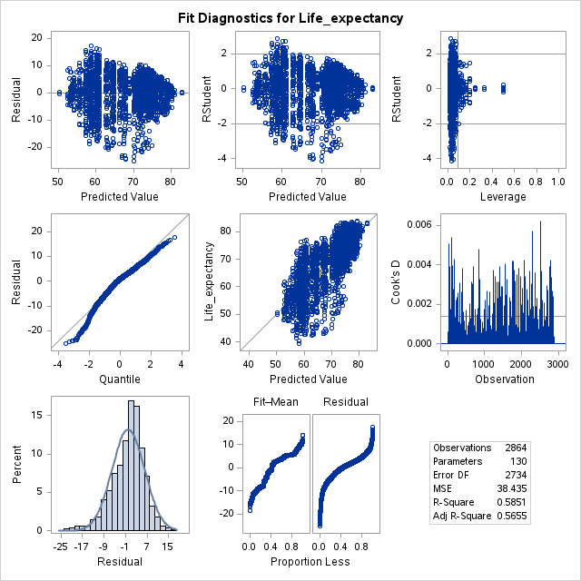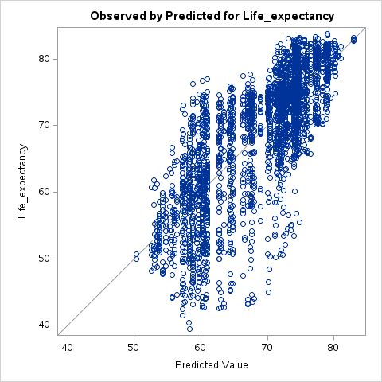There are many residual values. The data is also skewed towards right.

We will make the model better by adding more variables.

* **Dependent Variable**: Life_expectancy
* **Classification Variables**: Schooling, Country

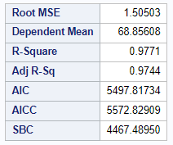Finally, we have found better model fit at 95% confidence level, R-square at 0.97 and Adjusted R-Square is also less than R-square. The data is also perfectly skewed now.

CODE:

proc glmselect data=WHOC2.ADMIT outdesign(addinputvars)=Work.reg_design;

class Schooling Country / param=glm;

model Life_expectancy=Schooling Country / showpvalues selection=none;

run;

proc reg data=Work.reg_design alpha=0.05 plots(only)=(diagnostics residuals

observedbypredicted);

where Schooling is not missing and Country is not missing;

ods select DiagnosticsPanel ResidualPlot ObservedByPredicted;

model Life_expectancy=&_GLSMOD /;

run;

quit;

proc delete data=Work.reg_design;

run;

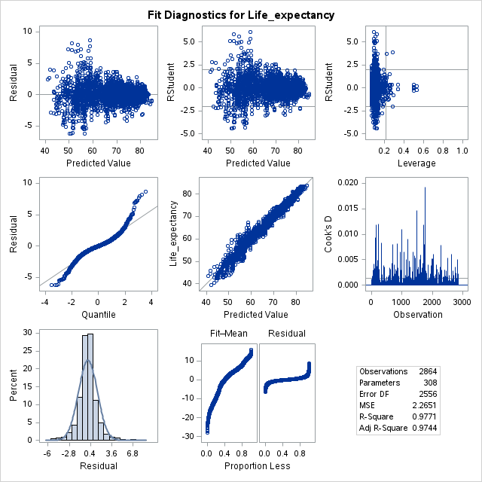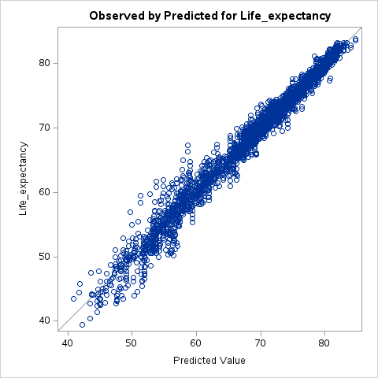

The plot shows a strong positive correlation between the observed and predicted values of life expectancy. The points closely follow the diagonal line, indicating that the regression model predicts life expectancy accurately.

**Fit Diagnostics for Life Expectancy (Right Panel):**

* + **Residual vs. Predicted Value**: The residuals appear to be randomly scattered around zero, suggesting that the model does not have a systematic error and is appropriately capturing the relationship between predictors and life expectancy.
  + **Normal Q-Q Plot:** The residuals roughly follow a straight line, indicating that they are approximately normally distributed.
  + The distribution of residuals on the bell curve appears roughly normal, supporting the assumption of normality in the regression model.
  + **Residual vs. Leverage**: There are some high-leverage points, but most observations have low leverage, indicating that the model is generally robust. However, high-leverage points might require further investigation.

**Insight:**

There is a strong positive correlation between years of schooling and life expectancy. More years of schooling are associated with higher life expectancy.

**INFERENCE 1:** Schooling is an important criterion in different countries (here grouped into regions) for better life expectancy.

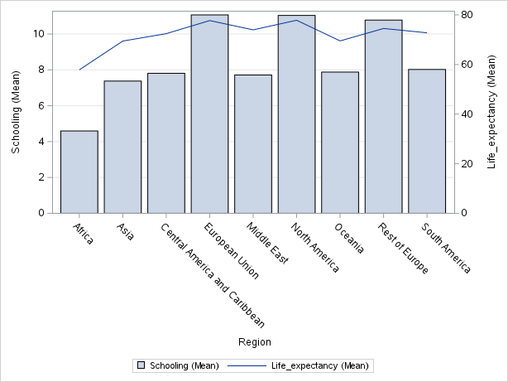

**Educational Policies to Enhance Life Expectancy:**

1. **Increase Access to Quality Education:** Implement policies to ensure free or affordable education for all, focusing on both primary and secondary levels. Improving education infrastructure, especially in rural and underserved areas, is crucial.
2. **Improve Educational Quality:** Invest in teacher training programs to enhance teaching quality. Introduce curricula that emphasize health education, nutrition, and hygiene, fostering healthier lifestyles from a young age.
3. **Promote Lifelong Learning and Adult Education:** Encourage continuing education and vocational training for adults, particularly focusing on health literacy and skills that can improve economic opportunities and well-being.
4. **Support Education for Girls and Women:** Implement policies that encourage girls' education, reducing gender disparities in schooling. Educated women tend to have better health outcomes and contribute positively to their families' health and well-being.

# Objective 4: Assess the influence of nutritional factors and child mortality on life expectancy rate

**Variables Involved**: Thinness_ten_nineteen_years, Thinness_five_nine_years, Infant_deaths, Under_five_deaths, Life_expectancy

**Model**: Multiple Linear Regression

**Interpretation and Inferences**:

* Evaluate how nutritional deficiencies (thinness) in different age groups, infant deaths and under-five mortality rates affect the life expectancy.
* Provide guidelines for nutritional programs to reduce child mortality.

## CAN WE RUN REGRESSION?

* **Dependent Variable**: Life_expectancy
* **Classification Variable**: Thinness_ten_nineteen_years, Thinness_five_nine_years, Infant_deaths, Under_five_deaths

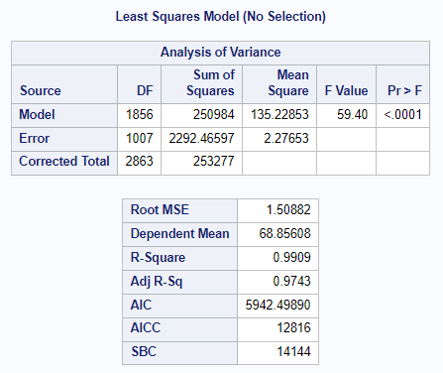We can run regression. The results are a good fit at 95% confidence level for analysis at R-Square 0.99, and Adjusted R-Square being less than R-Square at 0.97.

CODE:

proc glmselect data=WHOC2.ADMIT outdesign(addinputvars)=Work.reg_design;

class Thinness_ten_nineteen_years Thinness_five_nine_years Infant_deaths

Under_five_deaths / param=glm;

model Life_expectancy=Thinness_ten_nineteen_years Thinness_five_nine_years

Infant_deaths Under_five_deaths / showpvalues selection=none;

run;

proc reg data=Work.reg_design alpha=0.05 plots(only)=(diagnostics residuals

observedbypredicted);

where Thinness_ten_nineteen_years is not missing and Thinness_five_nine_years

is not missing and Infant_deaths is not missing and Under_five_deaths is not

missing;

ods select DiagnosticsPanel ResidualPlot ObservedByPredicted;

model Life_expectancy=&_GLSMOD /;

run;

quit;

proc delete data=Work.reg_design;

run;

**INFERENCE 1**: The points closely follow the diagonal line, suggesting that the model has a good fit.

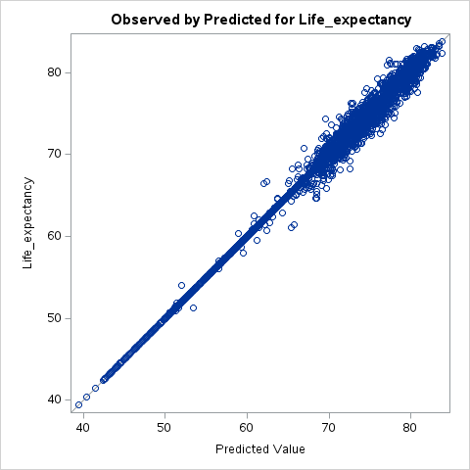**Correlation**: The chart shows a strong linear relationship between the observed and predicted values of life expectancy, indicating that the model predicts life expectancy accurately.

**Residuals vs. Predicted Value**: The residuals are randomly distributed around zero, which is a good sign, indicating no obvious patterns or biases in the model predictions.

**Normality of Residuals**: The histogram and Q-Q plot suggest that residuals are approximately normally distributed, which supports the assumptions of the regression model.

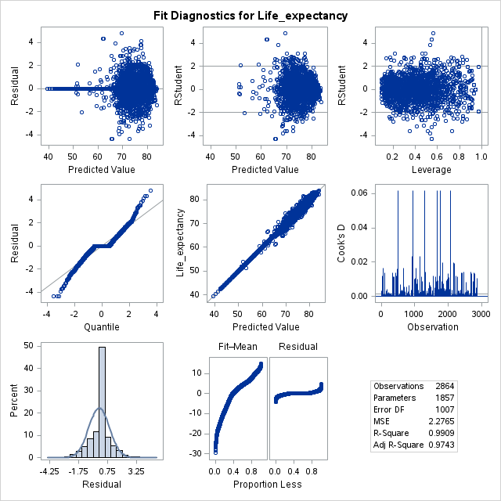**Scale-Location Plot**: Shows constant variance (homoscedasticity) of the residuals, which is another assumption of the linear regression model.

**Residuals vs. Leverage**: There are some points with high leverage, but no extreme outliers influencing the model disproportionately.

**Cook's Distance**: Indicates no data points have excessive influence on the regression model.

**Mortality Factors**:

* **Thinness (Ages 10-19 & 5-9)**: Likely negatively impacts life expectancy.
* **Infant and Under-Five Mortality**: Higher mortality rates are associated with lower life expectancy.

## Guidelines for nutritional programs to reduce child mortality:

* **Nutritional Programs**: Focus on improving nutrition in children and adolescents to reduce thinness rates.
* **Health Interventions**: Enhance healthcare access and quality to reduce infant and under-five mortality rates.

# Objective 5: Examine the effect of alcohol consumption on adult mortality

**Variables Involved**: Alcohol_consumption, Adult_mortality

**Model**: Linear Regression

**Interpretation and Inferences**:

* Analyze the relationship between alcohol consumption and adult mortality rates.
* Provide recommendations for alcohol consumption policies to reduce adult mortality.

## CAN WE RUN REGRESSION?

* **Dependent Variable**: Adult_mortality
* **Classification Variable**: Alcohol_consumption

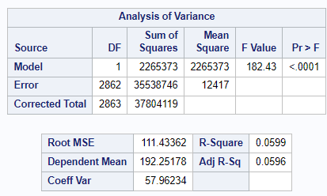The results at 95% confidence level for analysis are with R-Square 0.059, and Adjusted R-Square at 0.055. We cannot run linear regression but the results will not satisfy the objective of coming to conclusive reasons of adult mortality only with alcohol consumption as a variable.

CODE:

proc reg data=WHOC2.IMPORT;  
 model Adult_mortality = Alcohol_consumption;  
 title "Linear Regression for Alcohol Consumption Impact on Adult Mortality";  
run;

Therefore, we will run multiple linear regression with more variables as the probable reasons of adult mortality.

* **Dependent Variable**: Adult_mortality
* 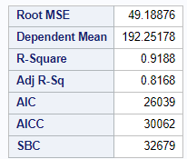**Classification Variable**: Alcohol_consumption, Incidents_HIV, Hepatitis_B

CODE:

proc glmselect data=WHOC2.ADMIT outdesign(addinputvars)=Work.reg_design;

class Alcohol_consumption Hepatitis_B Incidents_HIV / param=glm;

model Adult_mortality=Alcohol_consumption Incidents_HIV Hepatitis_B /

showpvalues selection=none;

run;

proc reg data=Work.reg_design alpha=0.05 plots(only)=(diagnostics residuals

observedbypredicted);

where Alcohol_consumption is not missing and Hepatitis_B is not missing and

Incidents_HIV is not missing;

ods select DiagnosticsPanel ResidualPlot ObservedByPredicted;

model Adult_mortality=&_GLSMOD /;

run;

quit;

proc delete data=Work.reg_design;

run;

Yes, now we can run the model as multiple linear regression to learn about the conclusive reasons of adult mortality across the world.

**INFERENCE**:

* **Correlation**: The chart shows a strong linear relationship between the observed and predicted values of adult mortality, indicating that the model predicts adult mortality with reasonable accuracy.
* **Model Fit**: The points are tightly clustered around the diagonal line, suggesting that the model has a good fit.

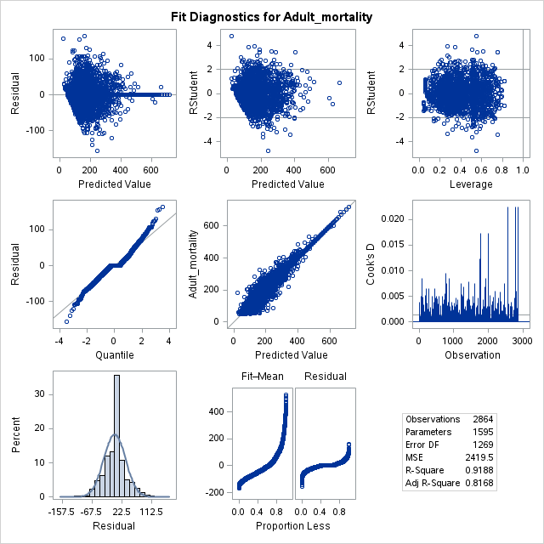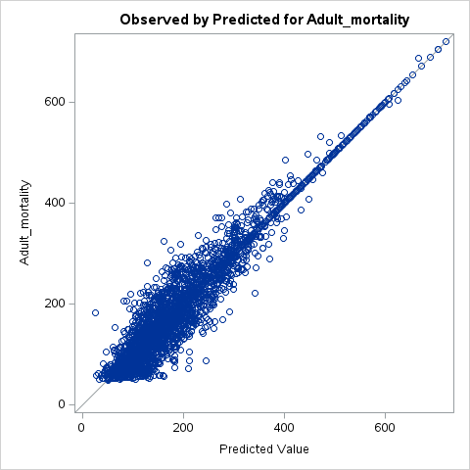

* **Residuals vs. Predicted Value**: The residuals appear to be randomly distributed around zero, which suggests that the model does not show systematic errors in the predictions.
* **Normality of Residuals**: The histogram and Q-Q plot suggest that the residuals are approximately normally distributed, which is a good sign for the validity of the regression assumptions.
* **Scale-Location Plot**: Shows a roughly constant spread of residuals, indicating homoscedasticity (constant variance) across predicted values.
* **Residuals vs. Leverage**: While there are some points with high leverage, they do not seem to significantly distort the model.
* **Cook's Distance**: There are no points with excessive influence on the model, suggesting a stable and reliable regression.

The model indicates a significant relationship between the predictors (alcohol consumption, incidents of HIV, and hepatitis B) and adult mortality rates. High alcohol consumption is likely associated with increased adult mortality, as the model captures this relationship well.

**Recommendations for alcohol consumption policies to reduce adult mortality:**

* + Implement public health campaigns to reduce excessive alcohol consumption.
  + Provide education on the risks of alcohol abuse and its association with increased mortality.
  + Increase support for addiction treatment and rehabilitation programs.
  + Strengthen policies to control and monitor alcohol sales and consumption, especially targeting high-risk populations.